MindMeld (+ What³ Debrief)
Make all the observations, patterns, and action ideas visual for everyone to see
Proposed by Chris McCarthy (designer and director of the Innovation Learning Network)

Not yet in LS microstructure format.

1) Pick a topic or challenge that is stuck

2. Mind map your topic or challenge alone using the What³ Debrief template (5 minutes). Use multi-color Post-It notes if available.
- What? What do you notice? What facts stand out about this challenge?
- So What? Why does it matter? Is there an important pattern or implication?
- Now What? What are your first steps or actions to address the challenge?

3) Get with a partner and create a new joint mind-melded map, repeating the What³ progression as you sift and sort observations, ideas, & actions (10 minutes)
4) Get with another pair and create a new "final" MindMeld, repeating the What³ progression as you sift and sort the material(10 minutes)
5) Groups of 4 share their final map via a gallery walk (5 minutes)

MindMeld map illustration below. Using color and shapes help everyone quickly see what is the same and what is different across the small groups. No need whatsoever for B O R I N G report outs.
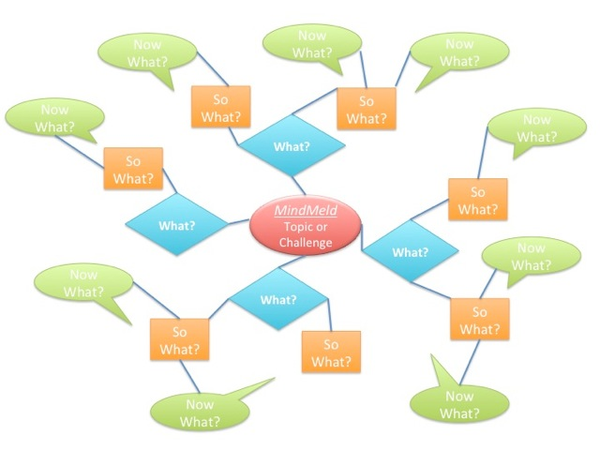

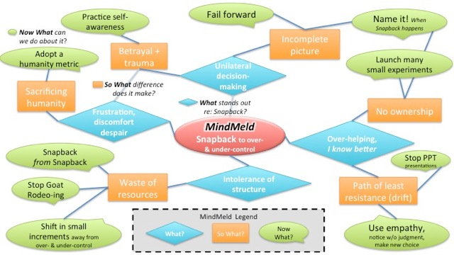

Above: Sample MindMeld illustration for the topic “Snapback to Over- and Under-Controlling Habits” developed at a Seattle LS User Group meeting field test. Four separate groups of 4 to 5 members contributed to this meta-MindMeld map. The results were pratical: members articulated very clear stopping- andstarting-actions.

